**Purchasing Portal User Manual**

# **Contents**

1 Setup for Budget Master 3

2 Setup for Approval 8

# 1 Setup for Budget Master

* Navigate to *Setup > Budget Master* from the menu bar. Portal will bring the user to the Budget Master Detailed List.

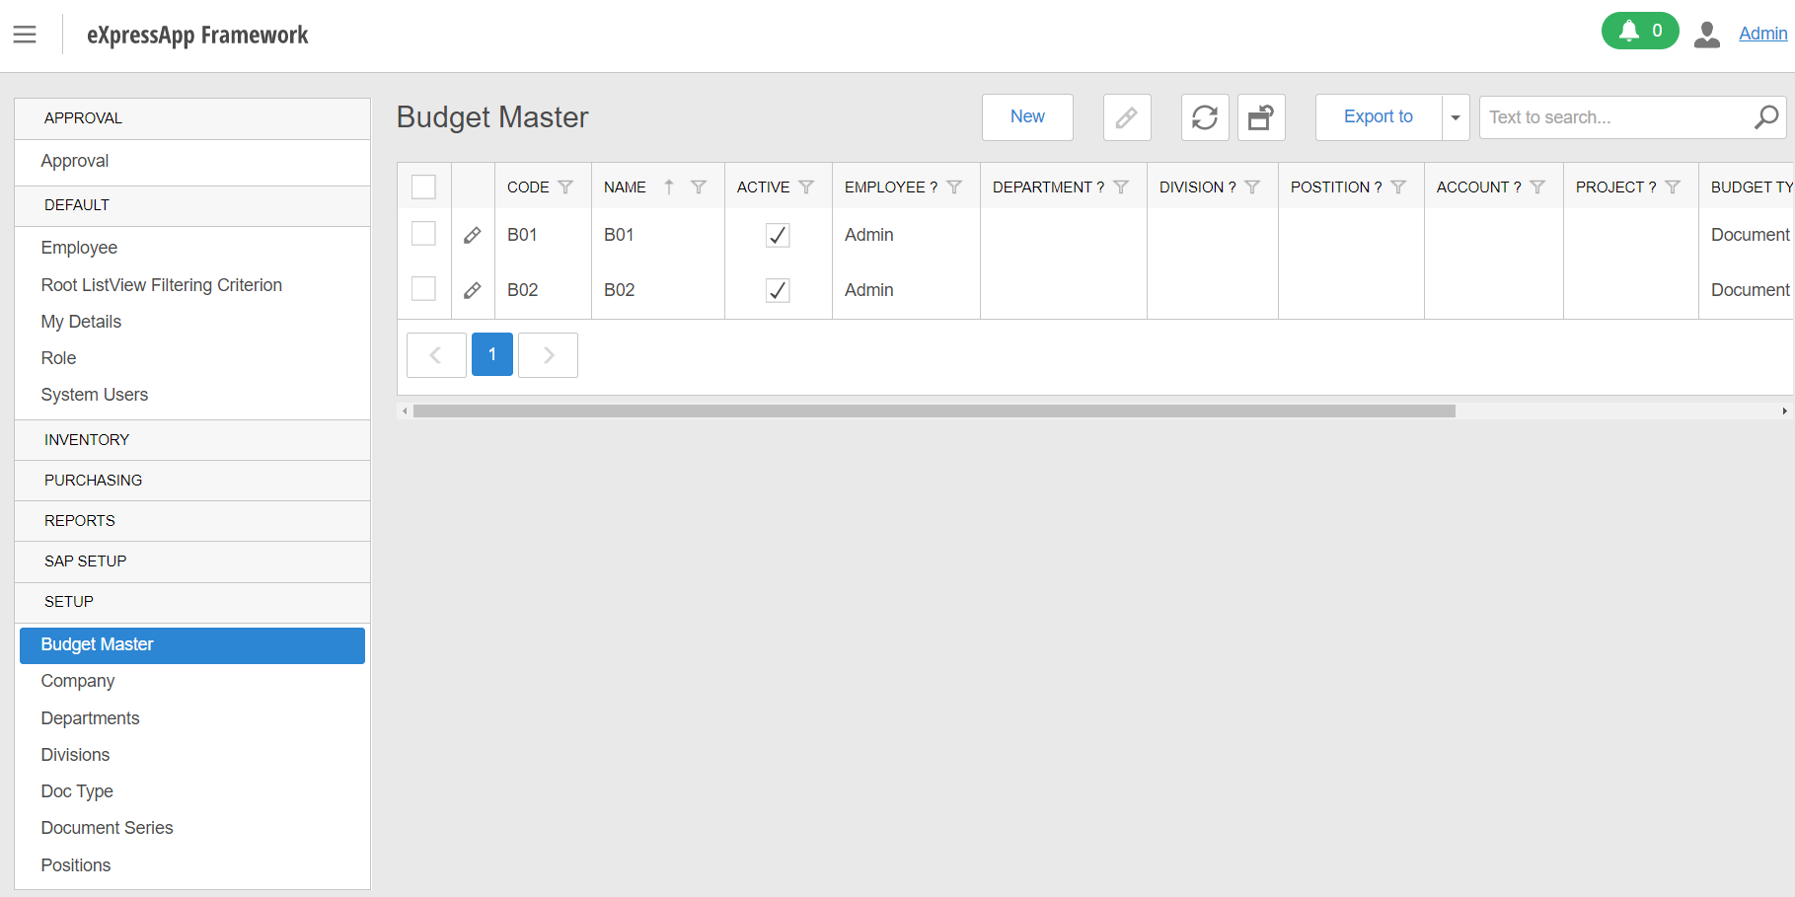

* The Budget Master Detailed List displays all the budget masters that have been created in the portal with Code, Name, Status(Active or Inactive), Employee, Department, Division, Position, Account, Project, Budget Type, Currency Code, Budget Amount.
* The user can select the pencil  beside the row to edit the details of the selected row.
* The user can choose to perform following :
  + : Create a New Budget Master.
  +  : Editing Existing Budget Master by selecting one row.
  +  : Refresh the Budget Master Template.
  +  : Reset the view of Budget Master Templates to default.
  +  : Export To several file types.
  + : Search the Budget Master details in the text.
* Click on the **New** Button to create a new Budget Master.

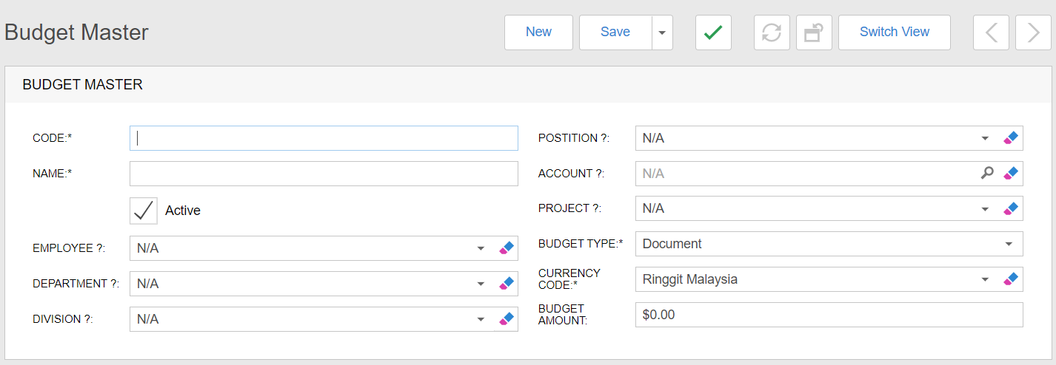

* The Budget Master Details Screen shows the required to fill in all the necessary details. E.g. Code, Name, Budget Type and Currency Code. Users can change or enter additional information such as the Budget Master is created based on Employee, Department, Division, Position, Account, Project and Budget Amount.
* The user can press to clear the text field, then the field becomes N/A.
* User can choose to press the button :
  + New : Recreate the new budget master.
  + Save : Save the new budget master details that have been filled.
  +  : Validate the filled details.
  + Switch View : Switch the view between editable and uneditable mode.
* To fill up the Employee field, the user can click theto expand the selection.

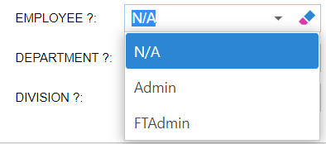

* To fill up the Department field, the user can click theto expand the selection.

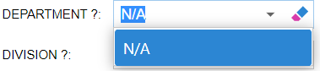

* To fill up the Division field, the user can click theto expand the selection.

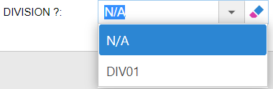

* To fill up the Position field, the user can click theto expand the selection.

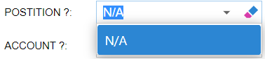

* To fill up the Account field, the user can click the magnifierto search and select the account by pressing the **OK** button.

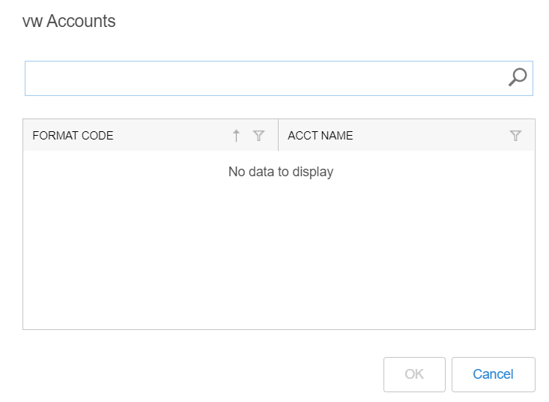

* To fill up the Project field, the user can click theto expand the selection.

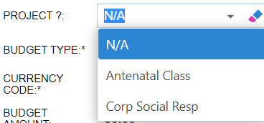

* To fill up the Budget Type field, the user can click theto expand the selection.

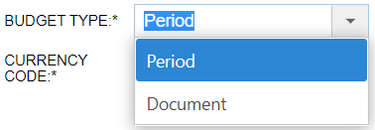

* To fill up the Currency Code field, the user can click theto expand the selection.

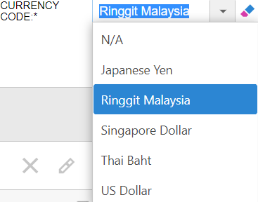

* If the user choose the **Budget Type** as **Document**, Budget Amount will appear to allow enter Amount.



* If the user choose the **Budget Type** as **Period**, a Budget Template will appear to allow adding a new Budget.

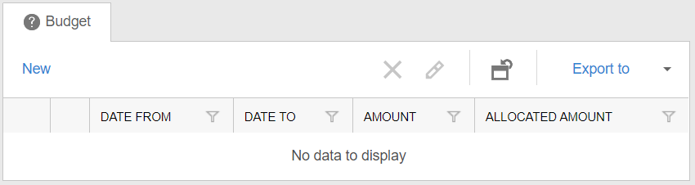

* For the Budget Template, the user can choose the button :
  + : Create New Budget ; an additional form will pop up for adding a new Budget.

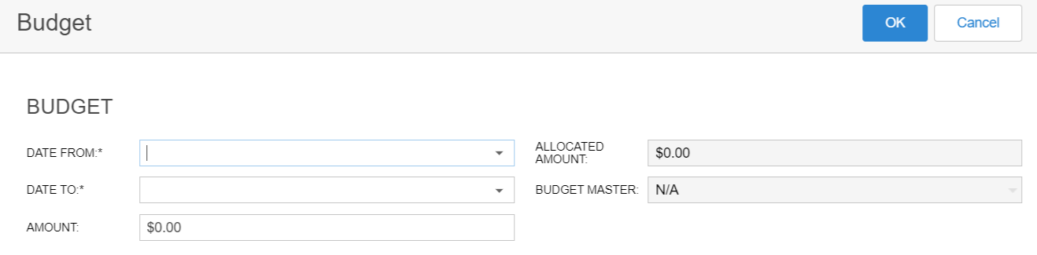

* The Budgets Form required to fill some necessary details. E.g. Date From and Date To. The user may enter some additional information such as Amount.
* Once the user fills up successfully by pressing the **OK** button, the Budget Template will display the new added Budget record.
* Moreover, the user can exit the Budget Form by pressing the **Cancel** button.
  +  : Delete Existing Budget by selecting at least one row.
  +  : Editing Existing Budget by selecting one row.
  +  : Reset the view of Budget Templates to default.
  + : Export to several file types.

# 2 Setup for Approval

* Navigate to *Setup > Approval* from the menu bar. Portal will bring the user to the Approval Detailed List.

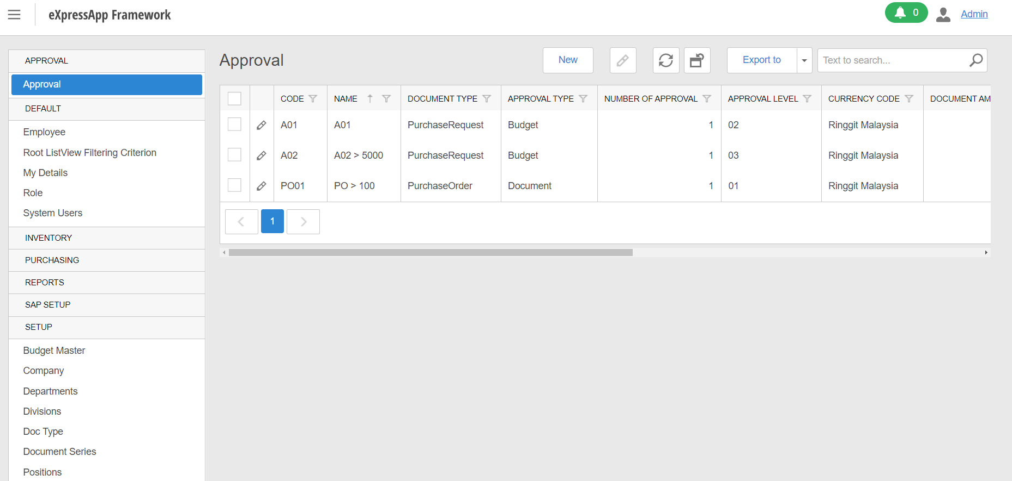

* The Approval Detailed List displays all the approval that have been created in the portal with Code, Name, Document Type, Approval Type, Number of Approval, Approval Level, Currency Code, Document Amount, Active Status, Override Following Level Status, Reject Status, Approval By, Appointed User and Approval Pos By Division.
* The user can select the pencil  beside the row to edit the details of the selected row.
* The user can choose to perform following :
  + : Create a New Approval.
  +  : Editing Existing Approval by selecting one row.
  +  : Refresh the Approval Template.
  +  : Reset the view of Approval Templates to default.
  +  : Export To several file types.
  + : Search the Approval details in the text.
* Click on the **New** Button to create a new Approval.

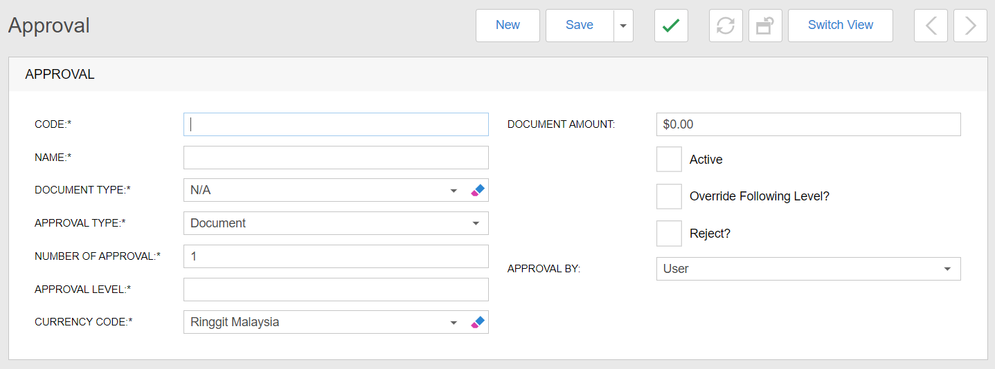

* The Approval Details Screen shows the required to fill in all the necessary details. E.g. Code, Name, Document Type, Approval Type, Number of Approval, Approval Level and Currency Code. Users can change or enter additional information such as the Approval is created based on Document Amount, Active Status, Override Following Level Status, Reject Status, Document Amount and Approval By.
* The user can press to clear the text field, then the field becomes N/A.
* User can choose to press the button :
  + New : Recreate the new Approval.
  + Save : Save the new approval details that have been filled.
  +  : Validate the filled details.
  + Switch View : Switch the view between editable and uneditable mode.
* To fill up the Document Type field, the user can click theto expand the selection.

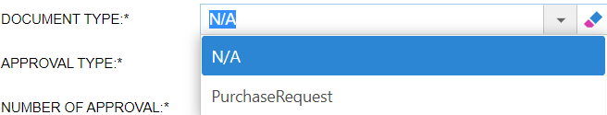

* To fill up the Approval Type field, the user can click theto expand the selection.

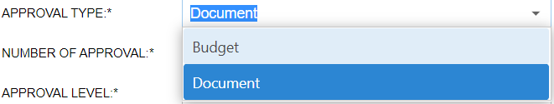

* To fill up the Currency Code field, the user can click theto expand the selection.

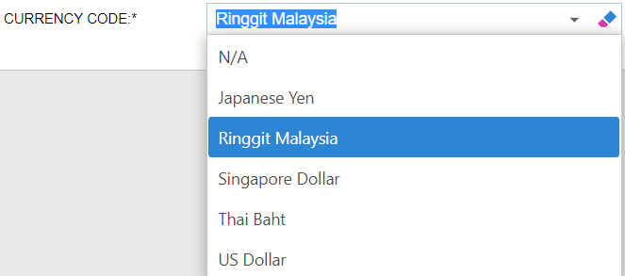

* To fill up the Approval By field, the user can click theto expand the selection.

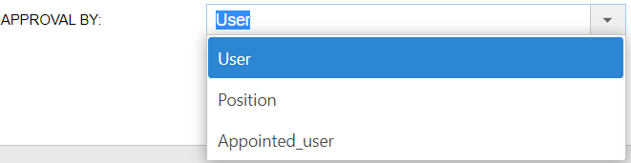

* If the user choose **Approval By** as **Appointed User**, the Appointed User field will appear to allow click the and choose a user.

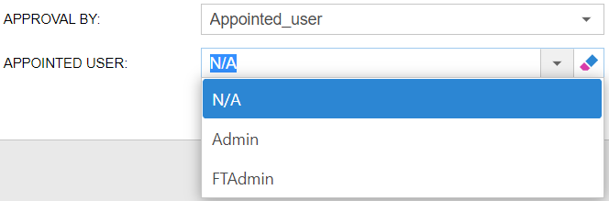

* If the user choose **Approval By** as **User**, the Approval User Template will appear to allow adding an user.

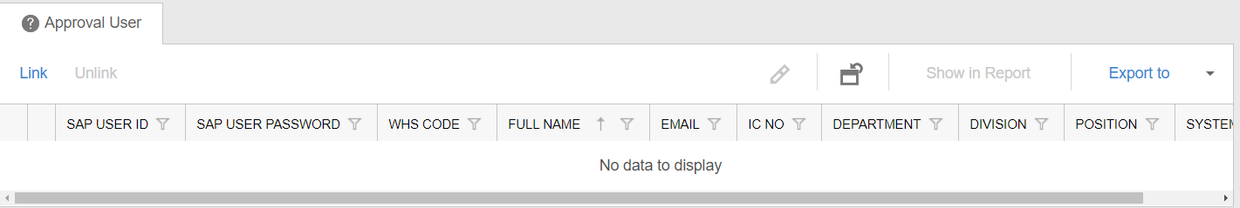

* For the Approval User Template, the user can choose the button :
  + : Link an approval user ; an Employee form will pop up to link an employee.

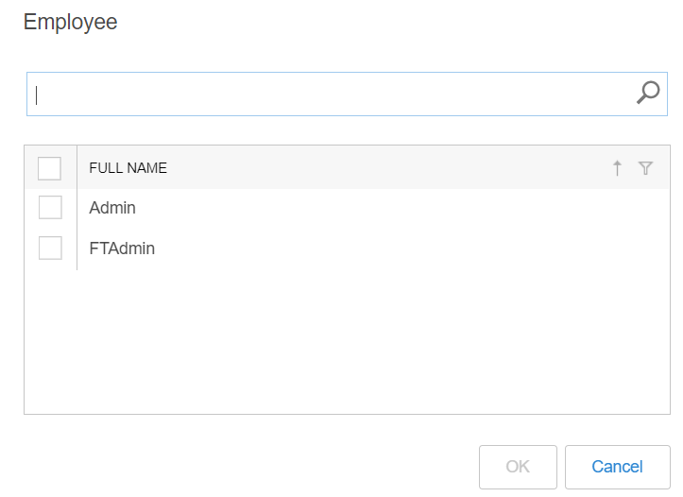

* The user can select one or more employees to link and become the approval user.
* By pressing the **OK** button, the Approval User Template will display the new linked Approval User.
* Moreover, the user can exit the Employee Form by pressing the **Cancel** button.
  +  : Unlink Existing Employee from the Approval User Template by selecting at least one row.
  +  : Reset the view of Approval User Template to default.
  + : Show the Employee Full Name in a list by selecting at least one employee for printing purposes.
  + : Export to several file types.
* If the user choose the **Approval By** as **Position**, the Approval Pos By Division field and Approval Position Template will appear.
* To fill up the Approval Pos By Division field, the user can click theto expand the selection.

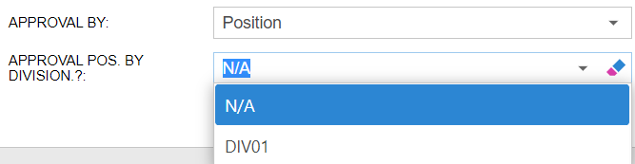

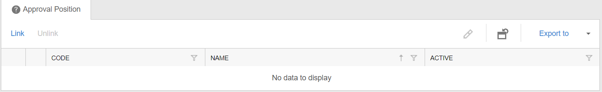

* For the Approval Position Template, the user can choose the button :
  + : Link an approval position ; a Position form will pop up to link a position.

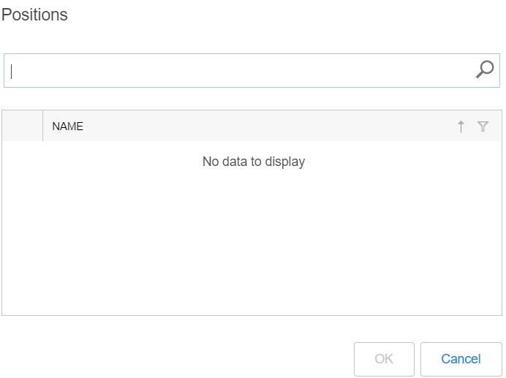

* The user can select one or more positions to link.
* By pressing the **OK** button, the Approval Position Template will display the new linked Approval Position.
* Moreover, the user can exit the Position Form by pressing the **Cancel** button.
  +  : Unlink Existing Position from the Approval Position Template by selecting at least one row.
  +  : Reset the view of Approval Position Template to default.
  + : Export to several file types.